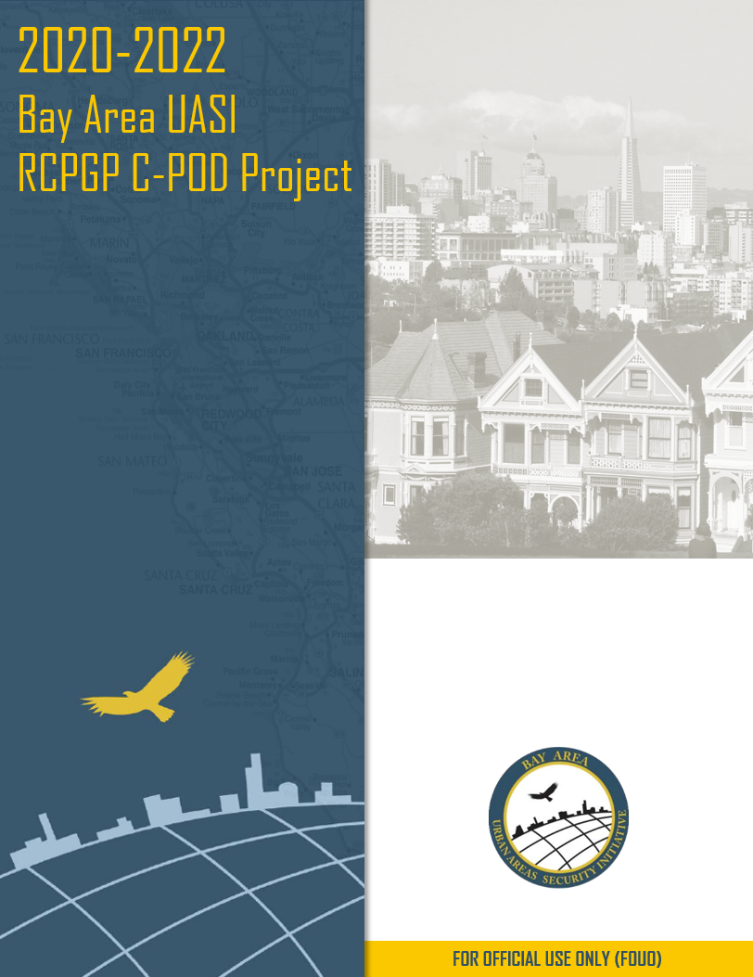
C-POD Planning: MOU/LOA Development
Guide

This document was prepared under a grant from FEMA’s Grant Programs Directorate, U.S. Department of Homeland Security, Regional Catastrophic Preparedness Grant Program. Content does not necessarily represent the official position or policies of FEMA’s Grant Programs Directorate or the U.S. Department of Homeland Security.

GUIDE TO WRITING A MEMORANDUM OF UNDERSTANDING (MOU)

In the context of disaster preparedness and response, Memoranda of Understanding (MOU) help establish formal agreements between organizations, in this case between Commodity Point of Distribution (C-POD) site operators, such as a jurisdiction, and landowners/managers. These established agreements allow organizations to collaborate, communicate, respond, and support one another during a disaster or other emergency. MOUs are used to document agreements between organizations and agencies to provide services, facilities and/or supplies that may be needed during or after a disaster or emergency. MOUs help to document an organization’s ability to respond to and sustain operations ensuring they can meet both their internal needs as well as those of the partner organization. It should be noted that during an incident, resources may be extremely constrained and may result in diminished capacity to fulfill an MOU. These MOUs help create and sustain avenues for communication and collaboration across community institutions.
This guide describes the basic elements of an MOU and provides an MOU template that can be adapted and customize for any disaster preparedness and response capability. The MOU template identifies the most commonly used sections, and additional sections can be included as needed. Not all MOUs will look the same, but the general concepts are transferrable. It is also recommended that involvement and review by legal counsel is included in the development of an MOU as appropriate for your organization and the services laid out in these agreements. This guide was adapted from the US Department of Homeland Security’s “Writing Guide for a Memorandum of Understanding.”

Introduction/Background

The Introduction section of the MOU briefly describes the content of the agreement. It describes the need for the collaboration, the community partners involved, and other stakeholders as appropriate. It should be a simple explanation of the agreement and how it fills a potential service or resource gap before, during, or after a disaster or emergency. Questions to consider:
- What is this MOU being created to support?
- Which community partners are participating in the MOU? This may Include public safety agencies, other governmental bodies, non-profits, or private sector services.
- Why is this MOU necessary?
- What are the summary agreements established by this MOU?

Purpose

The Purpose section should be a concise statement about what makes the MOU necessary. It explains how the community partners will collaborate to establish a new capability or ensure functioning of an existing capability, under what circumstances, and who will benefit from it. Questions to consider:
- For what C-POD Site does the MOU apply?
- Who will activate and oversee this MOU?
- When will the C-POD Site be used?
- How will the C-POD Site be used?
- Who are the intended beneficiaries?

Scope

The Scope section lists the community partners and jurisdictions (e.g., city, county, municipality, region) included in the agreement and describes their relationship. This section can also include who are the end users of the C-POD Site, level of command and control for the capability (if it applies), level of government involved, etc. Questions to consider:
- Who are the public safety, public service, and other governmental and non-governmental agencies that will have a role at the C-POD Site?
- Who is the end user of the C-POD Site?

Definitions

The Definition section includes the operational and technical specifications associated with the C-POD Site for which the agreement is written. Each sector should utilize their own terminology so that the terms of the agreement are as clear as possible, helping avoid confusion and uncertainty around any aspects of the agreement. Questions to consider:
- What are the technical and operational aspects of the C-POD Site? Consider including definitions for each.
- Are there any community-specific terms or acronyms worth including?

Policy

The Policy section of the MOU briefly describes the circumstances under which the C-POD Site should be used or activated. This section can also include leadership over the C-POD Site, activation, and other use cases. Questions to consider:
- Under what circumstances can the C-POD Site be used?
- When will the C-POD Site be used?
- Who can authorize the use of the C-POD Site?
- Are there operating procedures associated with this C-POD Site? Can specific procedures be referenced?

User Procedure Requirements

The User Procedure Requirements section states the obligations of this agreement. For agreements on sharing an enhanced C-POD Site, obligations may include training, exercises, user requirements, responsibilities for ensuring training, and awareness. Questions to consider:
- What are the training, exercise, and equipment requirements associated with participating in this MOU?
- Who will provide training and technical assistance if needed?
- Are there additional requirements?
- Are there any financial obligations that must be considered?
- Will backup partners and redundant MOUs provide additional benefit?

Oversight

The Oversight section outlines how community partners or jurisdiction will deploy the new or enhanced C-POD Site. It can also describe how the community partners can provide recommendations that affect the policy and whether other community partners accept or reject these recommendations. A description of internal agency policy regarding the use of the C-POD Site can also be included. Many of the questions below may not be applicable to simple agreements or those taking place between smaller organizations. However, careful exploration of these oversight questions should be undertaken during MOU development. Questions to consider:
- What governance structure oversees the use of this C-POD Site and enforces all requirements of this MOU?
- Who is the chair of this governance structure and how are they appointed, if appropriate?
- What are the participation requirements in this governance structure of community partners entering this MOU?
- How are issues affecting policy, recommendations, and/or subsequent change implemented by the governance structure?
- What is the voting method within the governance structure, if applicable?
- How do individual agencies establish oversight authority for the C-POD Site?

Responsibility for SOP Compliance

This section describes agencies’ responsibility to ensure Standard Operating Procedures (SOP) for the C-POD Site are followed. A standard operating procedure is a set of step-by-step instruction aimed at helping staff carry out routine operations. Questions to consider:
- Who is responsible for ensuring the SOPs associated with this C-POD Site are followed?
- Who is responsible for ensuring that individual agency personnel are trained appropriately?
- How will compliance be ensured?

Security

This section outlines which of the organizations, party to the MOU, are responsible for security at the site in question. The scope of this section should cover use of the site as a C-POD site and include deployment of security personnel and use of in-place security systems (e.g., lighting, fencing, CCTV) at the site. Considerations for traffic and emergency medical services should be covered in this section, as well.

Costs

This section outlines which of the organizations, party to the MOU, are responsible for the costs associated with the use of the site in-question, as a C-POD site. The scope of this section should include the costs of operating a C-POD site at the location, including cost of utilities (e.g., water, electricity, natural gas, waste). Consider utilizing an agreed upon Cost Allocation methodology.
This section should also include protocols for addressing damage to the site, while in use as a C-POD site, including responsibility/liability, use of insurance to cover damages, reporting, reference any applicable local policies/procedures, etc.
Lastly, include Disaster Recovery protocols, for ensuring use of the location as a C-POD site is covered in disaster proclamations and/or declarations.

Updates to the MOU

This section outlines how the MOU can be updated. It should include who has the authority to update the MOU, how updates will be made, how participating community partners will be notified of updates, and the types of updates that require signatures of all participating community partners. MOUs should be refreshed and updated during any leadership transitions by either signing party. Questions to consider:
- Who has the authority to update/modify this MOU?
- How will this MOU be updated/modified?
- How often does this MOU need to be reverified?
- Will any updates/modifications require the MOU to have a new signature page verifying the understanding of changes by each participating partner?
- Is a procedure in place to make new leadership aware of this MOU in the case of a leadership transition?

