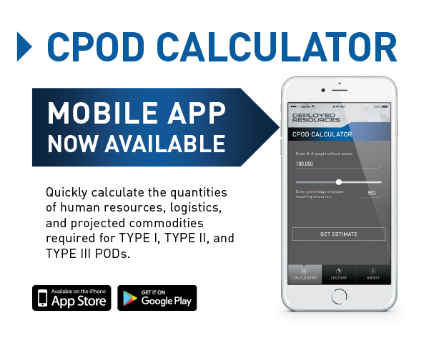

Get the CPOD Calculator app on App Store or Google Play

Commodity Points of Distribution (C-POD) Calculator
Developed in cooperation with Florida Division of Emergency Management. Utilizing POD concepts, course of instructions and forecast models developed by Florida and ADOPTED by FEMA and the USACoE nationally.



