
[Community Name]
Local Roadmap to Community Resilience
[Census Tract Number(s)]
[Date]
This template was prepared under a grant from the Federal Emergency Management Agency (FEMA) Grant Programs Directorate, US Department of Homeland Security (DHS), Regional Catastrophic Preparedness Grant Program (RCPGP). Content does not necessarily represent the official position or policies of FEMA’s Grant Programs Directorate or the US Department of Homeland Security.

Local Government and Community Partners
  Organization | Organization
Organization | Organization
Organization | Organization
Organization | Organization

Table of Contents
Local Government and Community Partners 2
Definitions 4
Bay Area Local Roadmaps Background 5
Regional Equitable Community Resilience Project Background 5
Local Roadmaps to Community Resilience Background 6
Process Timeline 7
Project Points of Contact 8
Community Profile 9
Map 10
Analysis of Hazards: Hazard 1 11
Background 11
Characteristics 11
Mapping 12
Dimension Tables 13
Analysis of Hazards: Hazard 2 16
Background 16
Characteristics 16
Mapping 17
Dimension Tables 18
Appendix A: Priority Project Matrix 21
Appendix B: Funding Opportunities 22
Appendix C: Acronyms and Abbreviations 29

Definitions
Capacity
The combination of all the strengths, attributes, and resources available within a community to manage and reduce disaster risks and strengthen resilience.
Community (* within chosen Census tract)
The “whole community” refers to individuals, community-based organizations, faith-based organizations, law enforcement, fire, medical response, local government, and the private sector.
Disaster
A disruption in the community involving human, material, economic, or environmental losses or impacts that exceed the community's ability to manage the event, using its own resources.
Exposure
The people, property, and systems that are located in areas with hazards, making them vulnerable to potential harm/loss.
Hazard
Natural or human-caused/made sources of harm and difficulty.
Resilience
A community’s ability to prepare for, adapt to, and recover from hazards.
Risk
The potential for damage, loss, or other impacts created by the interaction of hazards with the community. Risk is often expressed in relative terms, such as high, medium, or low.
Vulnerability
Conditions determined by physical, social, economic, and environmental factors or processes that increase the likelihood of a community experiencing the impacts of hazards.

Bay Area Local Roadmaps Background

Regional Equitable Community Resilience Project Background
The Bay Area Urban Areas Security Initiative (UASI) represents a region of 8 million people, a geographic footprint of 12 counties, and 3 densely populated urban cities of Oakland, San Francisco, and San Jose. The Bay Area UASI region has long been one of the most diverse in the nation; according to recent Census data, 60% of the Bay Area population identifies as a race/ethnicity other than “White alone, not Hispanic or Latino.”
Every year, California faces numerous large-scale emergency incidents, including some of the nation’s deadliest and costliest natural disasters. These emergencies, which disproportionately impact people in disadvantaged communities, only exacerbate existing inequalities. The Bay Area UASI was awarded Regional Catastrophic Preparedness Grant Program (RCPGP) funding through the Federal Emergency Management Agency (FEMA). The purpose of the RCPGP is to build regional capacity to manage catastrophic incidents by improving and expanding collaboration for catastrophic incident preparedness with a focus on equity, climate resilience, and readiness. Through this funding, in 2023-2024, the Bay Area UASI sponsored an Equitable Community Resilience project, focusing on the unique needs of disadvantaged communities and vulnerable individuals throughout the Bay Area to improve readiness for a disaster. Across several tasks, the project focused on:
Planning (Mitigation): Conduct a systematic process engaging the whole community, as appropriate, in the development of executable strategic, operational, and/or tactical-level approaches to meet defined objectives.
Housing: Implement housing solutions that effectively support the needs of the whole community and contribute to its sustainability and resilience.
Long-Term Vulnerability Reduction: Build and sustain resilient systems, communities, and critical infrastructure and key resources lifelines to reduce their vulnerability to natural, technological, and human-caused threats and hazards by lessening the likelihood, severity, and duration of adverse consequences.
Community Resilience: Enable the recognition, understanding, communication of, and planning for risk, and empower individuals and communities to make informed risk management decisions necessary to adapt to, withstand, and quickly recover from future incidents.

Local Roadmaps to Community Resilience Background
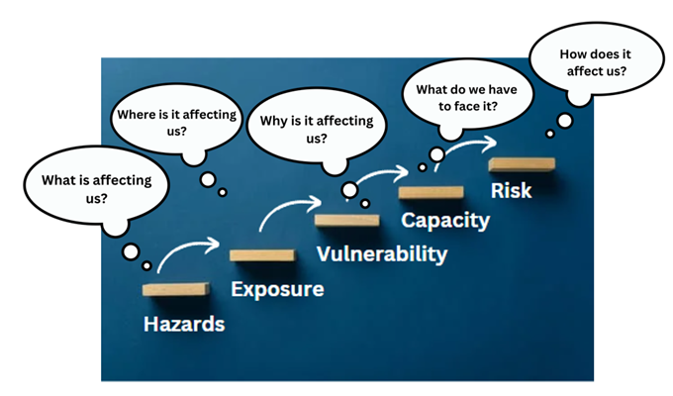
As part of the Equitable Community Resilience Project, the Bay Area UASI sponsored the development of 11 Local Roadmaps to Community Resilience across the region. A Local Roadmap to Community Resilience is a community-driven document that is developed, following an established process where communities become more resilient by understanding risks through self-assessment and analysis of hazards, exposures, vulnerabilities, and capacities. The process is action-orientated in that it supports communities moving from understanding risks to identifying preparedness and risk reduction action plans and/or projects.
The process and development of a Local Roadmap to Community Resilience is based on the International Federation of the Red Cross and Red Crescent Societies (IFRC) model, referred to as the Enhanced Vulnerability and Capacity Assessment (EVCA). Tailoring the process to the Bay Area, the UASI also sponsored the development of a Local Roadmap to Community Resilience Toolkit to encourage communities across the region to continue to use and document this process.
Figure 1: Local Roadmap to Community Resilience Development Process
Each community that participates in the development of a Local Roadmap to Community Resilience follows the same process, activities, and completion of milestones. Participants in the process may include nonprofit, faith- and community-based organizations, voluntary and community organizations active in disaster (VOADs/COADs), support service organizations, and local government. There are four milestones to developing a Local Roadmap to Community Resilience: (1) preparation, (2) assessment, (3) planning, and (4) document and share. A brief description of each milestone follows.

Milestone 1:Preparation
Milestone 1 initiated the project with the identification of the disadvantaged community or Census tract(s) of focus. The grant required the use of the Climate and Economic Justice Screening Tool (CEJST), which assesses several factors for each Census tract and determines whether the tract is considered “disadvantaged.” For additional information about the CEJST, click here: Climate and Economic Justice Screening Tool. Following the identification of the disadvantaged community, the project team gathered open-source hazard and demographic characteristics to inform an initial community profile, and a kick-off meeting was conducted.

Milestone 2: Assessment
Milestone 2 centered around the conduct of the Community Assessment Workshop, which included a discussion of the community profile, followed by the self-assessment process. The self-assessment process included identification of the hazard(s) of priority, and a discussion about the areas of exposure, community vulnerabilities, and capacities associated with the identified hazard(s).

Milestone 3: Planning
Milestone 3 focused on conducting the Community Action Planning Workshop, where community stakeholders participated in a visioning session and identified action plans and projects to enhance emergency preparedness and response in the disadvantaged community. These action plans and projects were then categorized by priority and potential funding needs.

Milestone 4: Document and Share
Milestone 4 completed the process, essentially finalizing the Local Roadmap to Community Resilience and distributing it to participating organizations and stakeholders.

Process Timeline
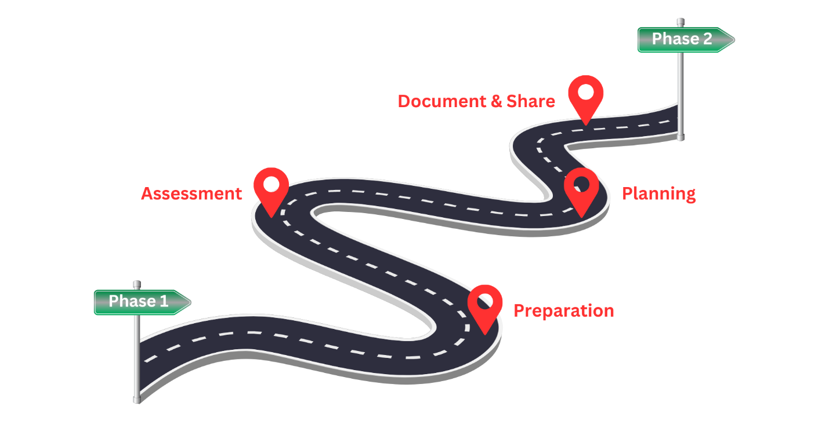
Figure 2; Process Timeline

Project Points of Contact
For additional information about this Local Roadmap to Community Resilience, please contact:
Name
Title/Role
Email address
Phone number

Name
Title/Role
Email address
Phone number

Community Profile
COMMUNITY
FEEDBACK
Add


The disadvantaged community identified during the preparation milestone, using the CEJST, was Census tract [add tract number]. This Census tract, along with neighboring tracts, is commonly known as [add neighborhood or community name], as it includes the communities of [add]. The tract borders are [add] to the North, [add] to the South, [add] to the East and [add] to the West. [Add a sentence or two about housing and business landscape.]
COMMUNITY
FEEDBACK
Add
According to the American Community Survey (ACS), there are [add] people living in the community. Approximately [add] of the population is considered a racial minority, with [add ethnicity details].
This community meets the criteria, as outlined in the CEJST, for being a disadvantaged community in the [add category or categories]. In particular, [add details about criteria met in CEJST]. For additional community-level data refer to the UASI Regional Resilience Tool.
COMMUNITY
FEEDBACK
Add

Map
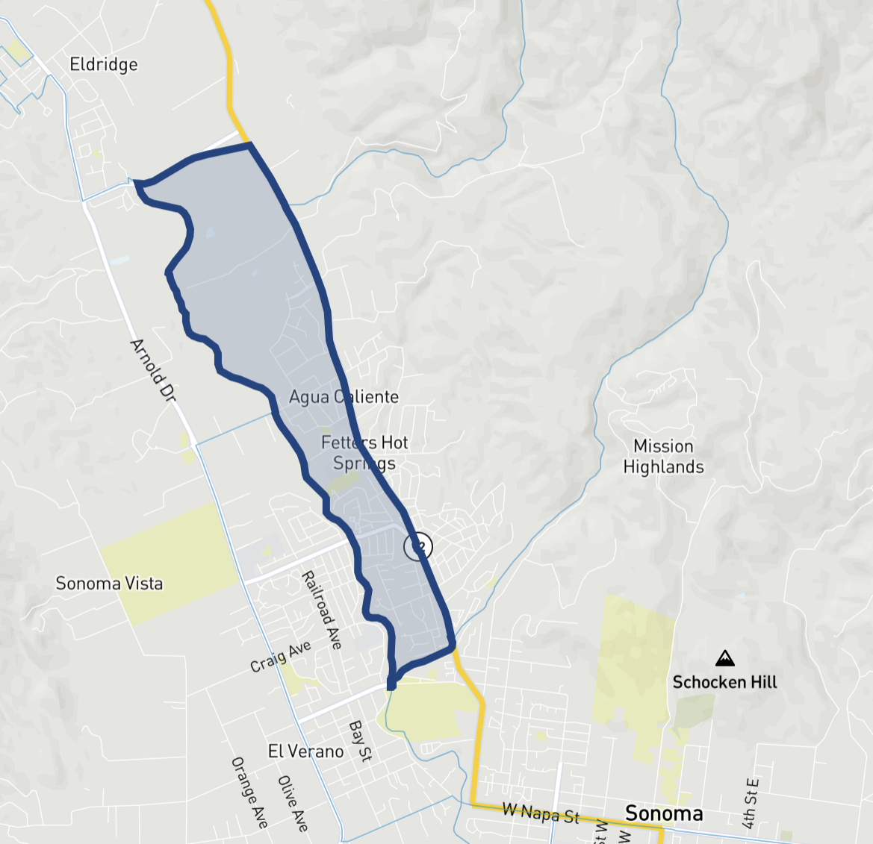
Figure 3: Disadvantaged Community Criteria Map
Climate and Economic Justice Screening Tool
Disadvantaged Community Criteria Met
 | Climate Change
 | Energy
 | Health
 | Housing
 | Legacy Pollution
 | Transportation
 | Water and Wastewater
 | Workforce Development

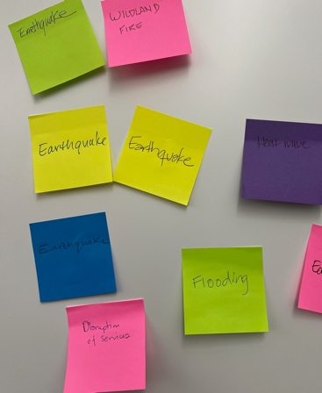
Analysis of Hazards: Hazard 1

Background
During the Community Assessment Workshop, the group identified [hazard] as a top hazard to focus their discussions, including the assessments of exposures, vulnerabilities, and capacities, and the identification of projects to positively impact community resilience. [Add 1-2 sentences about why the hazard was chosen.]

Characteristics
The hazard characteristics discussed by community stakeholders during the Community Assessment Workshop for [hazard] are outlined below.
Figure 4: Hazard Prioritization Activity
Cause/Origin
Warning Signs
Lead Time
Frequency
Period of Occurrence
Duration

Mapping
For the [hazard name] hazard the [area] is located in an area of high exposure.



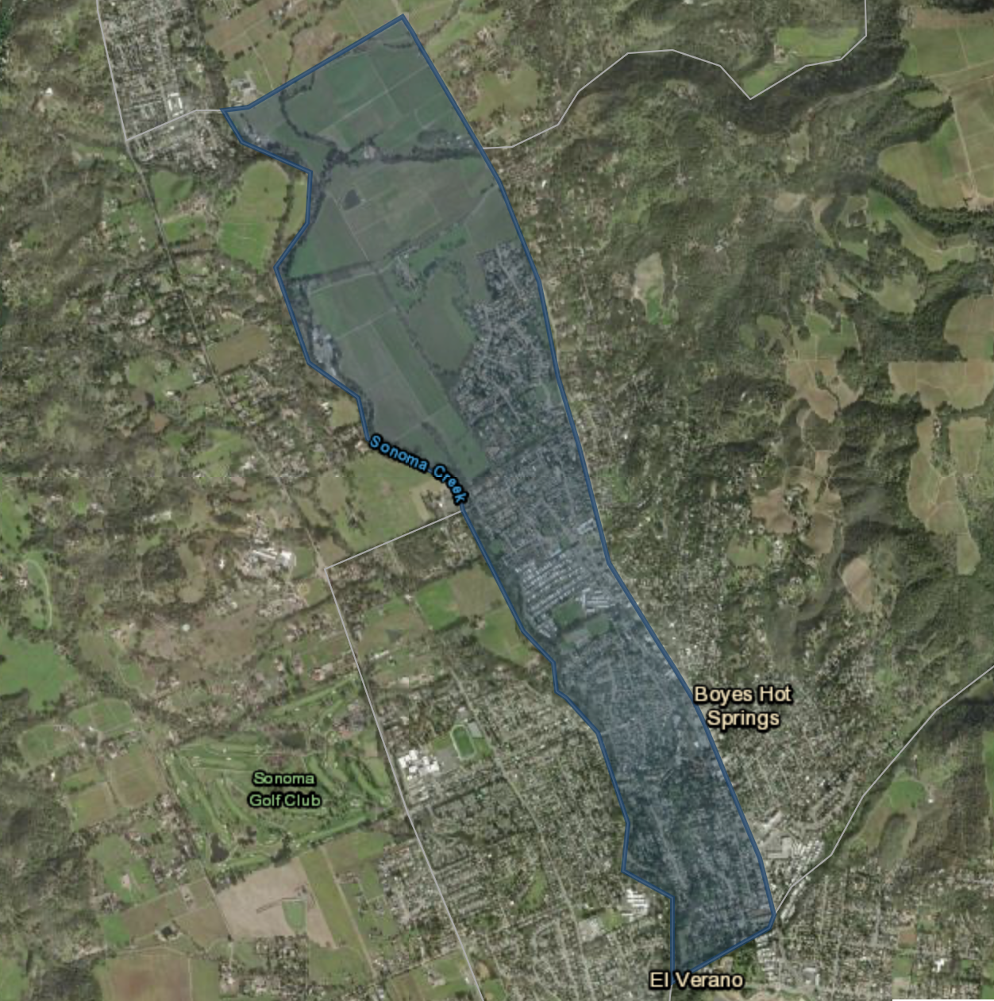
SYSTEMS
- Add
- Add
- Add
PROPERTY
- Add
- Add
- Add
PEOPLE
- Add
- Add
- Add
Figure 5: Map of High Exposure Area

Dimension Tables
The information contained within these tables was developed during the Community Assessment Workshop and the Community Action Planning Workshop.
VULNERABILITY: Why is it affecting us?
Dimensions | Impacts/Vulnerability | Ranking
Risk Management & Safety
i.e., First responders, Alert and Warning messages
Basic Needs
Food, water, health and housing
Social Capital
Strength of individual and community networks, church or cultural bonds
Infrastructure & Services
Water, electricity, roads, businesses and nonprofits
Natural Resources
Parks, rivers, geographic uniqueness

CAPACITY: What do we have to face it?
Dimensions | Capacity | Ranking
Risk Management & Safety
i.e., First responders, Alert and Warning messages
Basic Needs
Food, water, health and housing
Social Capital
Strength of individual and community networks, church or cultural bonds
Infrastructure & Services
Water, electricity, roads, businesses and nonprofits
Natural Resources
Parks, rivers, geographic uniqueness

RISK: How does it affect us? What do we want to do about it?
Dimensions | Risk | Solution/Project  (Bold text indicates a priority project )
Risk Management & Safety
i.e., First responders, Alert and Warning messages
Basic Needs
Food, water, health and housing
Social Capital
Strength of individual and community networks, church or cultural bonds
Infrastructure & Services
Water, electricity, roads, businesses and nonprofits
Natural Resources
Parks, rivers, geographic uniqueness

Analysis of Hazards: Hazard 2

Background
During the Community Assessment Workshop, the group identified [hazard] as a top hazard to focus their discussions, including the assessments of exposures, vulnerabilities and capacities, and the identification of projects to positively impact community resilience. [add 1-2 sentences about why the hazard was chosen]

Characteristics
The hazard characteristics discussed by community stakeholders during the Community Assessment Workshop for [hazard] are outlined below.
Figure 6: Hazard Prioritization
Cause/Origin
Warning Signs
Lead Time
Frequency
Period of Occurrence
Duration

Mapping
For the [hazard] hazard the [area] is located in an area of high exposure.



Figure 7: Map of High Exposure Area
SYSTEMS
- Add
- Add
- Add
PROPERTY
- Add
- Add
- Add
PEOPLE
- Add
- Add
- Add

Dimension Tables
The information contained within these tables was developed during the Community Assessment Workshop and the Community Action Planning Workshop.
VULNERABILITY: Why is it affecting us?
Dimensions | Impacts/Vulnerability | Ranking
Risk Management & Safety
i.e., First responders, Alert and Warning messages
Basic Needs
Food, water, health and housing
Social Capital
Strength of individual and community networks, church or cultural bonds
Infrastructure & Services
Water, electricity, roads, businesses and nonprofits
Natural Resources
Parks, rivers, geographic uniqueness

CAPACITY: What do we have to face it?
Dimensions | Capacity | Ranking
Risk Management & Safety
i.e., First responders, Alert and Warning messages
Basic Needs
Food, water, health and housing
Social Capital
Strength of individual and community networks, church or cultural bonds
Infrastructure & Services
Water, electricity, roads, businesses and nonprofits
Natural Resources
Parks, rivers, geographic uniqueness

RISK: How does it affect us? What do we want to do about it?
Dimensions | Risk | Solution/Project  (Bold text indicates a priority project )
Risk Management & Safety
i.e., First responders, Alert and Warning messages
Basic Needs
Food, water, health and housing
Social Capital
Strength of individual and community networks, church or cultural bonds
Infrastructure & Services
Water, electricity, roads, businesses and nonprofits
Natural Resources
Parks, rivers, geographic uniqueness

Appendix A: Priority Project Matrix
The following table lists the priority projects identified by the group during the Community Action Planning Workshop. These projects may be eligible for funding and/or grant writing technical assistance. To support this, the table includes potential grant types using six criteria: Climate Change, Infrastructure, Hazard Mitigation/Resilience Building, Public Health, Equipment, and Education/Training.
Project Name | Project Description | Potential Grant Types | Anticipated Funding | Impacted Hazard and Dimension |  | Intended Outcome

Appendix B: Funding Opportunities
The following tables highlight examples of Federal, State and local/regional grant opportunities that may provide insight to community partners and local government representatives. Refer to the Potential Funding Sources Matrix, which is a tool in the Roadmap to Community Resilience Toolkit.

Federal Grants
Grant Name | Building Resilient Infrastructure and Community (BRIC)
Source | FEMA (competitive) $1B total for Fiscal Year (FY)23
Eligible Applicants | State governments, local jurisdictions (singularly or grouped)
Description/  Requirements | The Building Resilient Infrastructure and Communities program aims to categorically shift the federal focus away from reactive disaster spending and toward research-supported, proactive investment in community resilience.  Through BRIC, FEMA continues to invest in a variety of mitigation activities with an added focus on infrastructure projects benefitting disadvantaged communities, nature-based solutions, climate resilience and adaption and adopting hazard resistant building codes.  Building Resilient Infrastructure and Communities Direct Technical Assistance (BRIC DTA) provides tailored support to communities and tribal nations that may not have the resources to begin climate resilience planning and project solution design on their own. Through process-oriented, hand-in-hand assistance, BRIC DTA will partner with communities interested in enhancing their capability and capacity to design holistic, equitable hazard mitigation solutions that advance community-driven objectives.  FEMA will offer wide-ranging non-financial support to BRIC DTA communities, including climate risk assessments, community engagement, partnership building, and mitigation and climate adaptation planning. Support for BRIC DTA communities can range from pre-application activities to grant closeout.
Duration | Fiscal Year
Types Of Activities | Projects that demonstrate innovative approaches to partnerships, such as shared funding mechanisms (various sources, including in-kind from public/private partners), and/or project design.
NOFO Release/ Rolling | Opens in Fall and closes early Winter. Application reviews are in Spring and selection is in the Summer.
Links | Must apply using FEMA Grants Outcome link - FEMA GO  https://www.fema.gov/grants/guidance-tools/fema-go

Grant Name | Sea Grant (Disaster Preparedness for Coastal Communities)
Source | National Oceanic and Atmospheric Administration (NOAA)
Eligible Applicants | State, tribal, territorial and local governments, institutions of higher education, and non-profit organizations in coastal states or territories. Resources from NOAA’s Climate Program Office, Office for Coastal Management, and National Sea Grant Office and its partners will be available to provide technical assistance to applicants and recipients to support these innovative efforts.
Description/  Requirements | $160K-$200K/per project. The Sea Grant Disaster Preparedness Program has several goals; grant requests should align with them.  Capacity Building Goal Statement: Build National Ocean Service (NOS) and partner capacity through delivering and facilitating training and exercises that increase readiness for all-hazard response and recovery operations, fostering a robust cadre of knowledgeable responders.  Objective 1 – Training: Develop, deliver, and evaluate a relevant preparedness and response training program that supports NOS and partner operations. Provide internal support and leadership to improve Office of Response and Restoration (OR&R) training.  Objective 2 – Exercises: Design and execute a comprehensive, multi-year exercise program designed to improve NOS’s and our partners’ preparedness, response, and recovery posture. Provide leadership within OR&R to ensure common understanding of divisional response and support roles and exercise OR&R preparedness.  Objective 3 – Risk Mitigation: Facilitate workshops and forums designed to inform and enhance science, tools, and/or decision making for disaster response and recovery.  Objective 4 – Deepen the Bench: Ensure a safe and qualified cadre of response, preparedness, and recovery specialists.
Duration | Fiscal Year
Types Of Activities | Capacity building (training/exercises that increase readiness for all-hazard response and recovery ops)
NOFO Release/ Rolling | Opens October; closes March
Links | https://seagrant.noaa.gov/inside-sea-grant/funding-opportunities/  https://seagrant.noaa.gov/wp-content/uploads/2023/06/DPP-Strategic-Plan.pdf  https://seagrant.noaa.gov/wp-content/uploads/2023/10/2024-27-CA-Sea-Grant-Strategic-Plan_WEB_508_02102023-508.pdf

State Grants
Grant Name | Senate Bill (SB) 1 Sea Level Rise Adaptation Planning Grant Program
Source | State Government
Eligible Applicants | Local governments, regional governments, and federally recognized tribal governments
Description/  Requirements | The SB 1 Grant Program aims to provide funding for sea level rise (SLR) adaptation planning to help prepare communities for the impacts of climate change. The Ocean Protection Council (OPC) aims to address this need by offering funding for a range of SLR planning activities. These fall into the following categories: Track 1/Adaptation Planning; Track 2/Implementation Projects. No match/no letter of intent is required. $200K - $1.5M/per award.
Duration | Maximum 2 years
Types Of Activities | - Track 1: Adaptation Planning, Phase 1: Pre-planning (explore, define, assess)  - Community Visioning, Vulnerability Assessment, Phase 2: Data Collection  - Data/Information Gathering, Phase 3: Planning (define adaptation frameworks and strategies)  - SLR Adaptation Plan, SF Bay Shoreline Adaptation Plan, Sector-Specific Adaptation Plan
NOFO Release/ Rolling | Ongoing  Track One proposals (Projects in the Pre-planning, Data Collection, and Planning Phases) will be accepted through a rolling, quarterly, non-competitive process, provided the proposals satisfy the Sea Level Rise Adaptation Criteria and requirements of the SB 1 Grant Program solicitation. Track Two proposals (Projects in the Implementation Project Phase) will be accepted through a competitive process starting in mid-late 2024, subject to availability of funding.
Links | https://www.grants.ca.gov/grants/senate-bill-1-sea-level-rise-adaptation-planning-grant-program/

Grant Name | Hazard Mitigation Grant Program (HMGP)
Source | State Government (funds originate at FEMA and are distributed/ administered by the Cal OES Hazard Mitigation Grant Program [HMGP] Unit.
Eligible Applicants | State agencies, local governments, special districts, and some private non-profits.
Description/  Requirements | HMGP funds plans and projects that reduce the effects of future natural disasters. Mitigation is the effort to reduce loss of life and property by lessening the impact of disasters before the next disaster, to reduce human and financial consequences later. Funds plans and projects that reduce the effects of future natural disasters.
Duration | 48 months
Types Of Activities | Wide variety; can include education/training, as well as planning activities.
NOFO Release/ Rolling | Ongoing
Links | https://www.grants.ca.gov/grants/hazard-mitigation-grant-program/

Local/Regional Grants
Grant Name | Community Development Block Grant Disaster Recovery (CDBG-DR)
Source | U.S. Department of Housing and Urban Development (HUD)
Eligible Applicants | Cities, counties, tribes, states in areas impacted by presidentially declared disasters (especially low income areas)
Description/  Requirements | Rebuild disaster-impacted areas and provide crucial seed money to start the long-term recovery process. Flexible grants. Since CDBG-DR assistance may fund a broad range of recovery activities, HUD can help communities and neighborhoods that otherwise might not recover due to limited resources.
Duration | Typically, by Fiscal Year
Types Of Activities | Wide variety - infrastructure repair/bolstering; mitigation efforts related to climate change; education/training of emergency management personnel.  Disaster Relief - long term-recovery; restoration of infrastructure; housing; economic revitalization
NOFO Release/ Rolling | Based on federal appropriation
Links | https://www.hud.gov/program_offices/comm_planning/cdbg-dr  https://www.hud.gov/sites/dfiles/CPD/documents/CDBG-DR-Fact-Sheet.pdf

Grant Name | Vanguard Charitable
Source | Vanguard Charitable
Eligible Applicants | Community-based [501c3] organizations
Description/  Requirements | Vanguard Charitable manages two mission-driven funds with assets that are held outside of donor-advised funds (DAFs). These funds focus on two areas: intermediate to long-term disaster relief and the advancement of philanthropy. The Sustainable Disaster-Relief Fund (SDRF) was established in 2006 to aid communities hit by natural disasters. This fund supports communities as they rebuild and establish necessary infrastructure to better handle the impact of a repeat disaster. Sustainable Disaster-Relief Fund (SDRF). $10K-$30K/project.
Duration | Grants are one-time payments. Ideally funds are to be spent within a one-year period, but, if necessary, the grant recipient organization may determine to use the funds over multiple years.
Types of Activities | Various
NOFO Release/ Rolling | Funding decisions are usually finalized by early July
Links | https://www.vanguardcharitable.org/pif-sdrf-faq

Appendix C: Acronyms and Abbreviations
ACS American Community Survey
BRIC Building Resilient Infrastructure and Community
CalOES California Governor’s Office of Emergency Services
CBOs Community-Based Organizations
CDBG-DR Community Development Block Grant Disaster Recovery
CEJST Climate and Economic Justice Screening Tool
COAD Community Organizations Active in Disaster
DAF Donor-Advised fund
DHS US Department of Homeland Security
DTA Direct Technical Assistance
EVCA Enhanced Vulnerability and Capacity Assessment
FEMA Federal Emergency Management Agency
FY Fiscal Year
HMGP Hazard Mitigation Grant Program
HUD US Department of Housing and Urban Development
IFRC International Federation of the Red Cross and Red Crescent Societies
NOAA National Oceanic and Atmospheric Administration
NOFO Notice of Funding Opportunity
NOS National Ocean Service
OPC Ocean Protection Council
OR&R Office of Response and Restoration
POC Point of Contact
RCPGP Regional Catastrophic Preparedness Grant Program
SB Senate Bill
SDRF Sustainable Disaster-Relief Fund
SLR Sea Level Rise
UASI Urban Areas Security Initiative
VOAD Volunteer Organizations Active in Disaster

Column includes anticipated funding level using the following thresholds: High ($100,000 or more), Medium ($50,000 - $99,000) and Low ($49,000 or less).

